Seth Thompson

CST105

10/28/2018

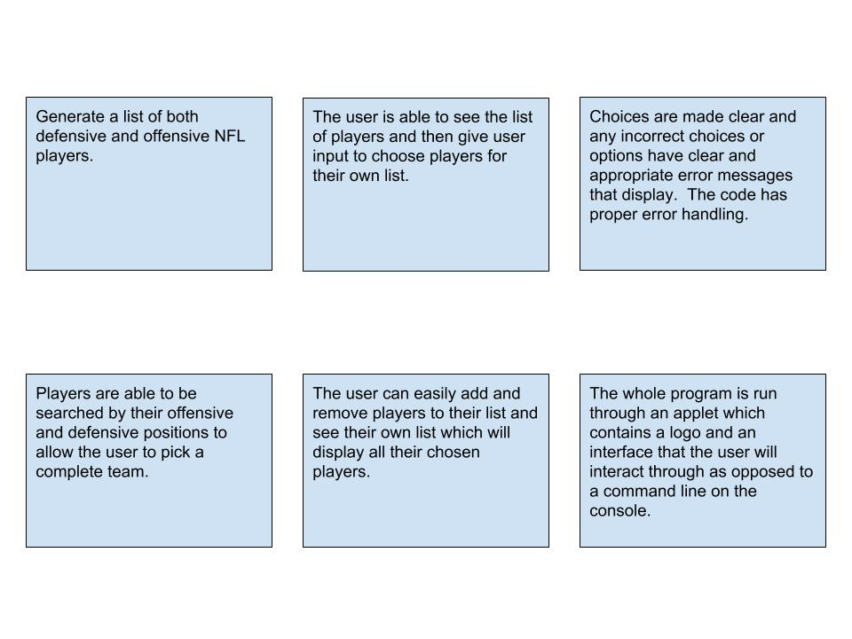Dennis Attawia

This storyboard should show the flow of the application that the user will interact with. I’m not too sure about what all visually I can do with a Java interface and application, but I would like to have a single window to start the application and then two viewing areas. On the right side of the screen is where your team list is displayed. On the left side of the screen is where all the players are listed and where players can be searched from. You can then check the players you wish to add to your team and they will be added to your side of the screen and then you can either uncheck them from the full list or your team list and they will be removed from your team. I dunno if I’ll be able to do all of that, but I think so. Then I should just need to have errors display for names that don’t exist and for choosing too many defensive and offensive players.

Overall I think a storyboard is useful mainly to highlight the points that must be met in order to finish the project and still meet all the criteria. I don’t know much about what I can do application-wise, but as far as a basic outline is concerned I feel pretty confident with this one and very relieved to get this outlined.